Cora Cummings Gauvin, Head Coach
Cora started her competitive swimming career at age five and has swum at many levels as she climbed her way to the prestige of a Division I swimmer. Injury brought her years as a swimmer to a close. However, along with being a swimmer, her coaching resume includes 13 years at the Burlington Tennis Club as Head Coach, 6 years for Green Mountain Aquatics (USA club team), 2 seasons as an assistant at the University of Vermont Women’s Swimming & Diving Team, and 2 years at Wilbraham & Monson Academy as Assistant Coach.

Krysta Downs, Assistant Coach
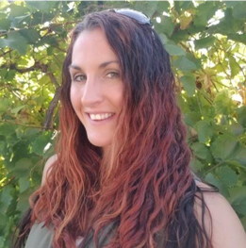
Krysta began competitive swimming at 11 for the Springfield Sharks. She quickly transitioned to the Mass Aquatics Club. A season later, she went to the Holyoke YMCA where she competed twice at the YMCA Nationals Long Course Meet. In high school, she helped set a Western Mass relay record, as well as, swimming two personal and two relay high school records at Westfield High. In her time in aquatics, she has served as the Springfield Sharks assistant coach for two seasons, Aquatics Director at two YMCA's. She is currently the Aquatics Coordinator at the Farmington Valley YMCA in Granby, Ct.
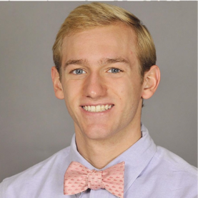
Ricky Billig, Assistant Coach
Ricky began swimming on a team similar to the Marlins when he was in
4th grade and has swum almost every day since. He is originally from Sudbury, MA, where he swam on the town team. In high school, he coached his town team, swam for a USA club team
(North Shore Swim Club), and swam for his high school team. His accolades for his high school career are placing 1st multiple times in the 200 IM at the conference meet, placing 3rd in the 200 IM at states, and 5th in the 100 Back at states. On his club team, he was ranked top 6 in New England for multiple events and held a couple of team records. He attended Providence College, where he swam on their Division 1 team. He currently holds the 100-back record. His passion for swimming has not left him. He brings his love for the sport, energy, past experiences to the pool deck, where he looks forward to working with every swimmer and parent!

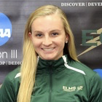
Julianne Gordon, Assistant Coach
A senior nursing student at Elms College, Julianne is from Plaistow, NH. She has been a competitive swimmer since she was four years old and still swims for her college team. Julianne has experience teaching swim lessons and working with swim teams since 2014. Her future goals are to be a nurse in the Neonatal Intensive Care Unit.

